1. Get the post url from reqres:

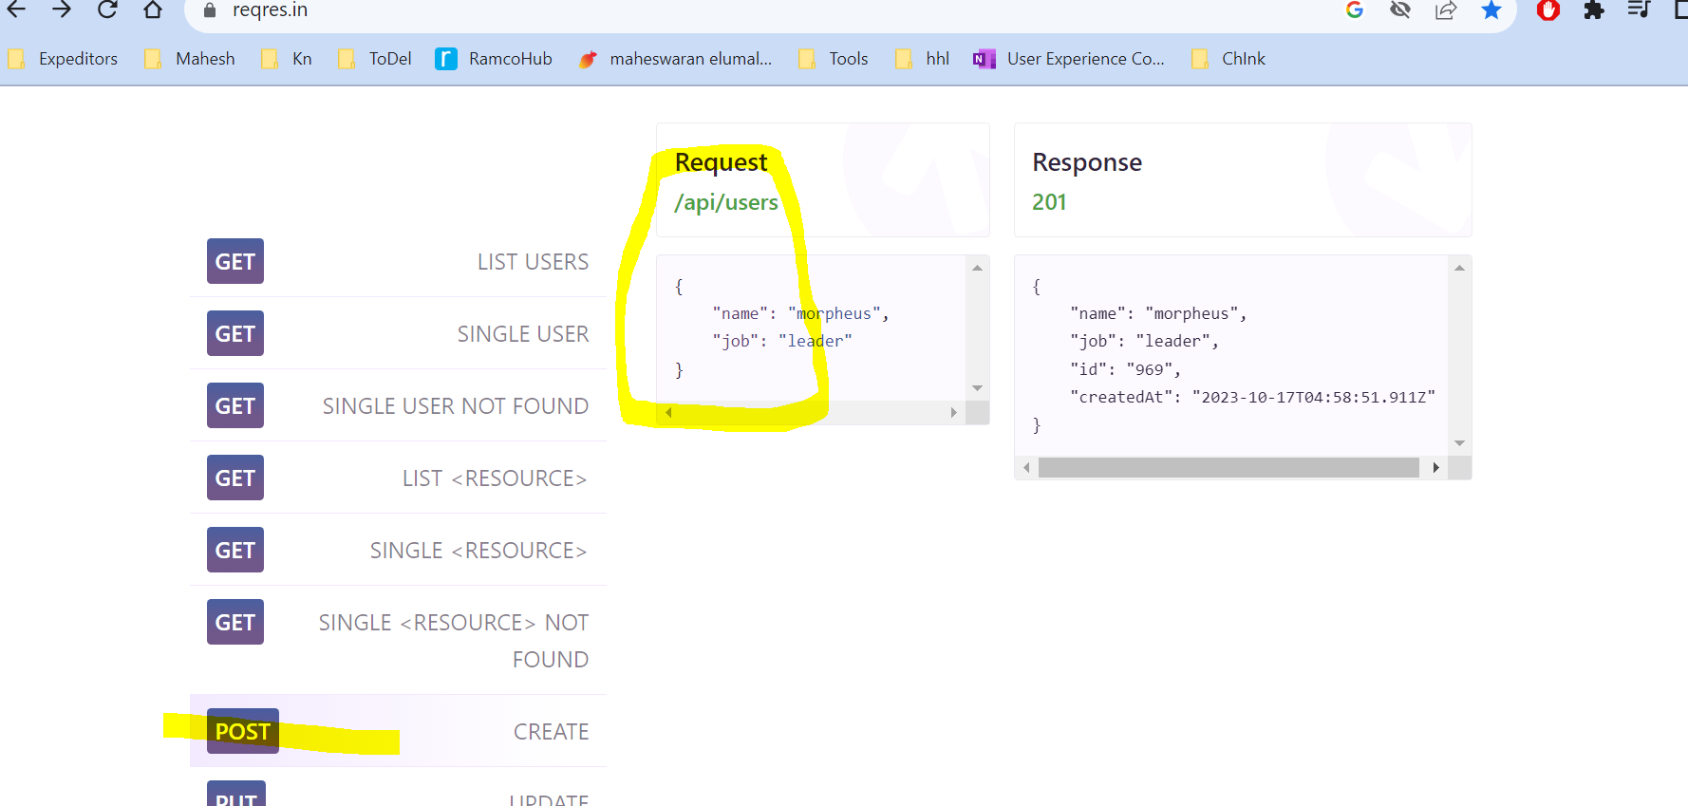

1. Copy the url:

1. Copy body from reqres:

1. Paste in postman and send the request:

1. Now check the response

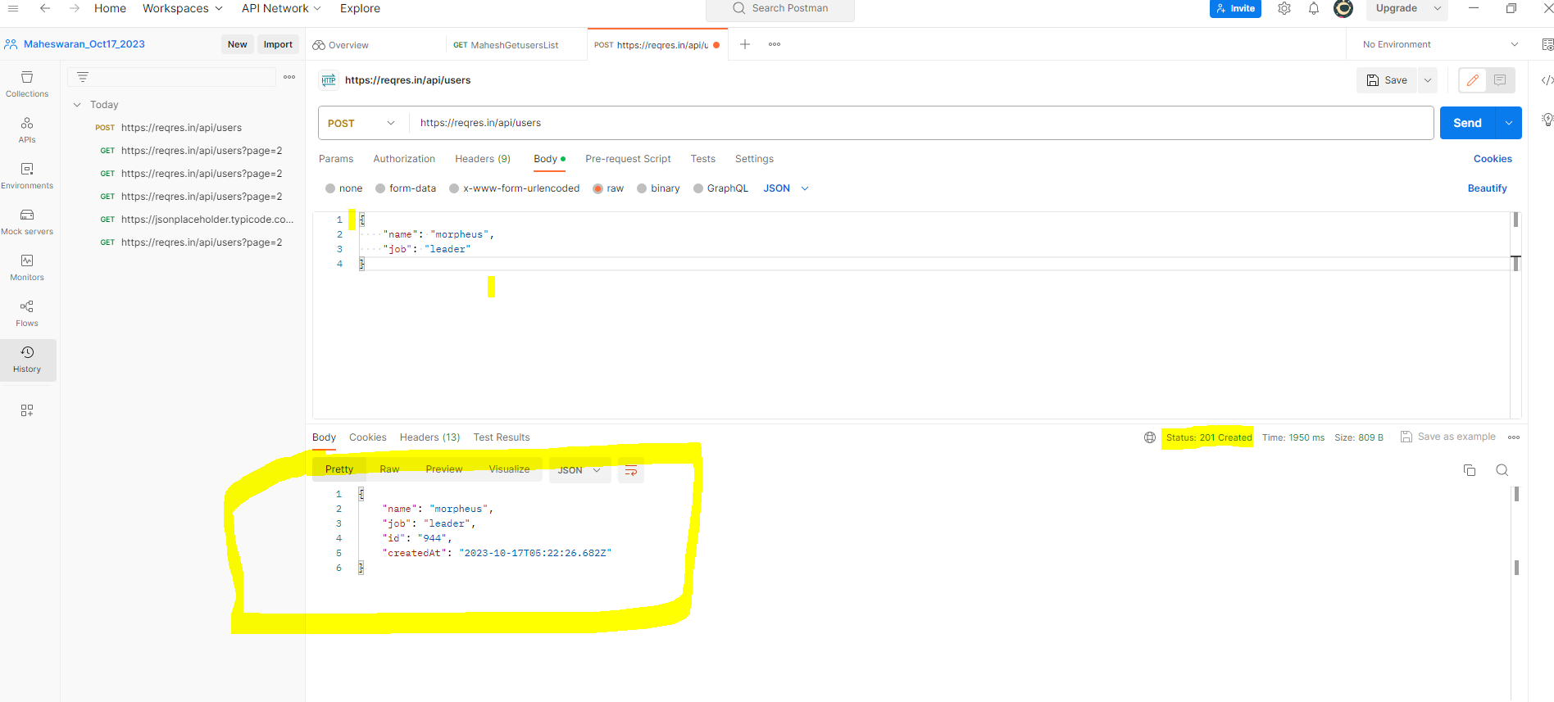

1. Run test for status code:200, we got 201 hence it will fail

1. Now if I change test condition to 201, test will pass

